# ATS – Asia Ticketing Script

# Support Guide

Version No: 12.0

# Prepared by: Nikki Bromwich

# Date: 28 February 2012

Table of Contents

**Purpose of the Document** 3

**ATS Overview** 3

**ATS Logic** 3

**ATS Error Messages** 4

**General Errors** 5

1. Please Sign In 5

2. Valid PNR not found 5

**Name Screen Errors** 6

3. Name Error 6

**Flight Screen Errors** 7

4. Segment Select Error 7

5. Fare Quote Errors 7

6. Waitlisted Error 8

7. Open Segment Error 8

8. No Valid Fare – Private Fare Quote Error 8

9. Net Ticket Data Does Not Exist Error 9

10. No Valid Fare – Published Fare Quote Error 9

11. Segment Error 10

**Update Screen Errors** 10

12. Baggage Error 10

13. Ticket Modifier Script Errors 11

14. ASF (Actual Selling Fare) Invalid format Error 11

**Support Log – Debug Log** 12

# Purpose of the Document

This document is the support guide for ATS – Asia Ticketing Script V12.0. It describes in detail the common errors experienced and the relevant trouble shooting steps.

# ATS Overview

ATS automates the quoting and pre-ticketing process for Agency Private Fares by allowing the Travel Agent to manipulate the fare data according to special codes loaded into the OTHER NOTES section of the APF contract & also by information inputted by the agent, through the ATS GUI itself. For a full description of the APF fields please refer to the ATS Fare Loading guide.

# ATS Logic

ATS creates a manual filed fare by completing the following steps. Understanding this logic will assist you in troubleshooting the script.

1. Quotes the APF fare (FQ….)
   1. Using the passengers selected on the Name Screen
   2. Using the fare quote modifiers selected on the Flight Screen
2. Reads the OTHER NOTES field of the APF fare (FQN, followed by FN1/ALL)
3. Quotes the Published fare (FQ@....:N)
   1. Using the fare basis from the PFBC field of the APF fare
4. Converts this to manual fare build, to read the data then ignores it. (*FB2, followed by FBI)
5. Cancels the published fare (FX2)
6. Converts the APF quote into a manual fare build (*FB1)
7. Updates the fare calculation line (FBUFC/…)
   1. Using the fare calculation line from the published fare quote
   2. Adding data found in the FC1 – FC3 fields in the APF fare
8. Updates the fare basis (FBUFB/Y)
   1. Using the fare basis from the APF fare, if no value found in the TFBC field
   2. Using the fare basis from the TFBC field, if one is found in APF fare
9. Updates the ticket designator (FBUTD1/… +TD2/…)
   1. Using the designator from the APF fare if one existed
10. Updates the fare amount. (FBUFARE/…)
    1. The value is taken from the published fare quote
11. Updates the equivalent fare amount if required. (FBUEQ/…)
12. Updates the manual fare build (FBUTTL/)
13. Updates the endorsement field (FBUEB/…)
    1. Using the value from the EB field in the APF fare
14. Updates the validity dates (FBUNVA1/…) (FBUNVB1/…)
15. Files the manual fare build (FBFALL)
16. Updates the tour code (TMU1TC…)
17. Updates the form of payment (TMU1F…)
18. Add the historical notepad fields (NP.H**ATS…)
19. Receives and ends the PNR (R.ATS)

# ATS Error Messages

There are 3 types of errors found in ATS.

* **Script Errors** – which display in red text at the top of the relevant screen. These are a result of missing data.



These are fixed within the script itself, by following the instructions in red.

* **Script Errors** – which display in a pop-up box. These errors are shown when the script is not permitted to / or can not perform a set action.

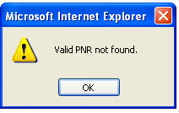 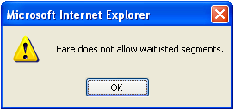

These are fixed by following the instructions in the box.

* **Host Errors** – which display in a pop-up box. These occur if the host can not perform the relevant entry.

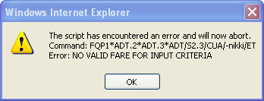

Host errors are always displayed in the following format:

“The script has encountered an error and will now abort.

Host Command: <%CrypticCommand%>

Host Error: <%ErrorReturnedByHost%>"

These are host errors, and would be need to be investigated in host.

When the agent clicks on ‘**OK**’ to exit the error, the following pop-up box is displayed. This allows the agent to retry the fare quote (returns the agent to the Name Screen), or to cancel the quote (exits the script).

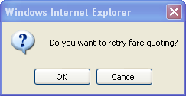

Please Note: Below you find a list of the common errors and the troubleshooting steps to address these, however these are not all errors returned by the script. If an error is returned and you can not determine how or why please refer to the *debug log*.

This log records all host entries and responses performed by the script (full details on P13 of this guide).

# General Errors

## Please Sign In

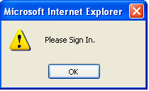

This message is displayed if the user is not signed into Galileo Desktop and clicks on the Custom Viewpoint toolbar ATS button to initiate the script.

Click “**OK**” to close the error window and then

* Sign into Galileo Desktop
* Retrieve the PNR
* Then click on the ATS button to run the script again.

## Valid PNR not found



This message is displayed when the agent clicks on the Custom Viewpoint toolbar ATS to initiate the script however an active PNR/Booking file is not present.

Click “**OK**” to close the error window and then

* Retrieve a PNR
* Then click on the ATS button to run the script again.

# Name Screen Errors

## Name Field Script Error



This message is displayed when the agent clicks **Next>>** on the name screen, and multiple passenger type codes are selected.

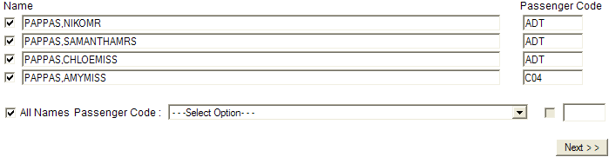

Fix:

* Select only passengers with the same PTC
* Click **Next>>**

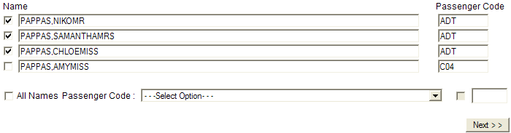

# Flight Screen Errors

## Segment Select Script Error



This message is displayed when the agent clicks **<<Get Fare Quote>>**, and no segments have been selected.

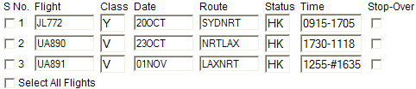

Fix:

* Select relevant segments to quote
* Click on **<<Get Fare Quote>>**

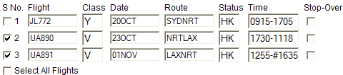

## Fare Quote Script Errors



### 

### 

### 

### 



These messages are displayed when the agent clicks on **<< Get Fare Quote>>.** It is shown when the relevant modifier tick box is selected, but the agent does not enter a value in the text box.

Fix:

* Add data in the relevant text box
* Click on **<<Get Fare Quote>>**



## Waitlisted Error



This message is displayed when the agent clicks on the **<<Get Fare Quote>>** button, if waitlisted segments are not allowed in Fare Notes and the PNR has waitlisted segments.

Click on “**OK**” to close the error window.

The segments having a Request Code “HL”,”AL” or “BL” are considered as waitlisted segments.

## Open Segment Error

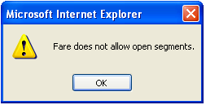

This message is displayed when the user clicks on the **<<Get Fare Quote>>** button, if Open segments are not allowed in Fare Notes and the PNR has open dated segments.

Click on “**OK**” to close the error window.

## No Valid Fare – Private Fare Quote



This message is displayed when the user clicks on the **<<Get Fare Quote>>,** when no valid private fare quote can be found.

Click on “**OK**” to close the error window.

Steps:

* Does the fare quote in host.
  + Yes – this is a script error and would need to be escalated
  + No – this is a host error and normal private fare troubleshooting should be completed.
* Is there an Agency Private Fare loaded fare for this itinerary?
  + - Yes. Is the user selecting the correct modifiers to quote this fare?
    - No. The script can only work with fares loaded through APF, therefore a fare must be loaded

## Net Ticket Data Does Not Exist

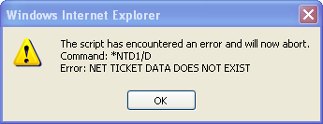

This message is displayed when the user clicks on the **<<Get Fare Quote>>** button, if a fare quote is found, which does not have net data (no *NTD data).

Click on “**OK**” to close the error window

Steps:

* When you quote the fare in host does it have Net Data (*NTD)?
  + Yes – this is a script error and would need to be escalated
  + No – the script has quoted the wrong fare

* If the script has quoted the wrong fare
  + Is there an APF fare for this itinerary?
    - Yes - what modifiers are required to quote this?
    - No. The script can only work with fares loaded through APF, therefore a fare must be loaded

## No Valid Fare – Published Fare Quote

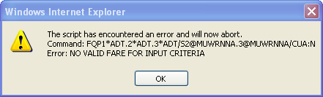

This message is displayed when the user clicks on the **<<Get Fare Quote>>,** when no valid published fare quote can be found.

Click on “**OK**” to close the error window.

The script performs a published fare quote to determine the fare amount to print on the ticket. It reads the fare basis code from the PFBC field of the OTHER NOTES field and forces the PNR to quote.

Steps:

* Does the fare quote in host?
  + Yes – this is a script error and would need to be escalated
  + No – this is a host error.
* If this is a host error:
  + Does a valid published fare exist? Validate the fare basis by doing a fare display
    - Yes, this is a script error and would need to escalated
    - No, the fare basis in the PFBC field of the APF contract needs to be updated

## Segment Error

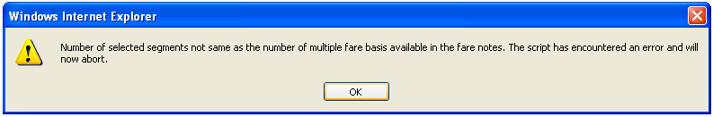

This message is displayed when the user clicks on the “<<Press Here to Update>>” button, if the number of selected segments is not same as the number of multiple fare basis available in the fare notes.

Click on “**OK**” to close the error window.

Steps:

* Check the number of fare basis in the PFBC field of the APF contract.
  + Does this match to the number of segments in the itinerary
    - Yes – this is a script error and would need to be escalated
    - No – the private fare would need to be updated

# Update Screen Errors

## Baggage Error



This message is displayed when the agent clicks **<<Press Here to Update>>**, and no baggage data has been entered.

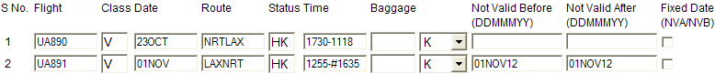

Fix:

* Add baggage data
* Click on **<<Press Here to Update>>**

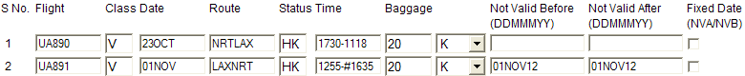

## Ticket Modifier Script Errors



### 

### 

### 

### 

### 

These messages are displayed when the agent clicks on **<< Press Here to Update>>.** It is shown when the relevant modifier tick box is selected, but the agent does not enter a value in the text box.



Fix:

* Add data in the relevant text box
* Click on **<<Press Here to Update>>**



## ASF (Actual Selling Fare) Invalid format

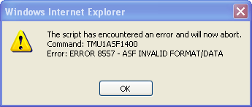

This message is displayed when the user clicks on the **<<Press Here to Update>>** button, if the format is incorrect.

Click on “**OK**” to close the error window.

Fix:

* Update the format. In the above case add decimals - 1400.00
* Click on **<<Press Here to Update>>**

Please Note: The same is true for other fields, such as Invoice Fare, Net Fare etc.

# Support Log – Debug Log

The debug log is used for trouble shooting as it shows a list of all entries performed by the script and the host response returned. It is opened as notepad file.

The log is created as part of the installation and by default is found in the following path.





By reviewing the debug log you can determine why the script failed if you are not familiar with the error returned by the script.

